# Homework #1: Windows Server 2016 & SQL 2017 VM Creation

|  |
| --- |
| * This is an individual assignment, and is worth 20 points. * The due date is 2:30 (sec 01) / 7:00 (sec 76) on Tue, Jan 21st. * You should use the “CIS 483 Homework #1 VM Creation-Tasks.docx” file to provide your outcomes. * Use the following naming convention: homework, underscore, last name, first initial, and extension (e.g., Homework #1_ImG.docx). If you do not follow the convention, I will deduct 1.0. * Do not copy any of the sample screenshots provided as illustrations. * You are not allowed to do this assignment during the class. |

**(TASK #1: 5 points)** Login to the Windows Server, and take a screenshot of the first screen.

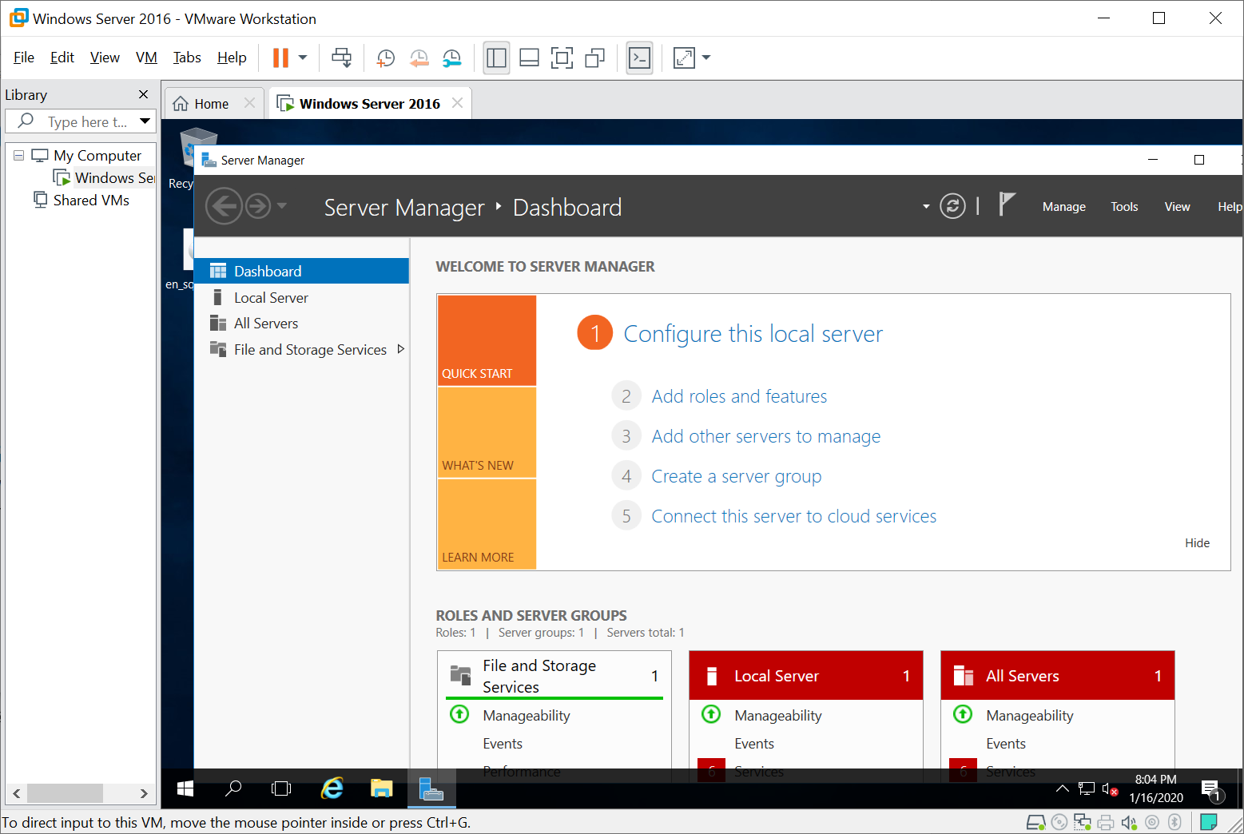

**(TASK #2: 5 points)** Run the following queries. Show the results in a screenshot. You must show that the installation is SQL Server 2017.

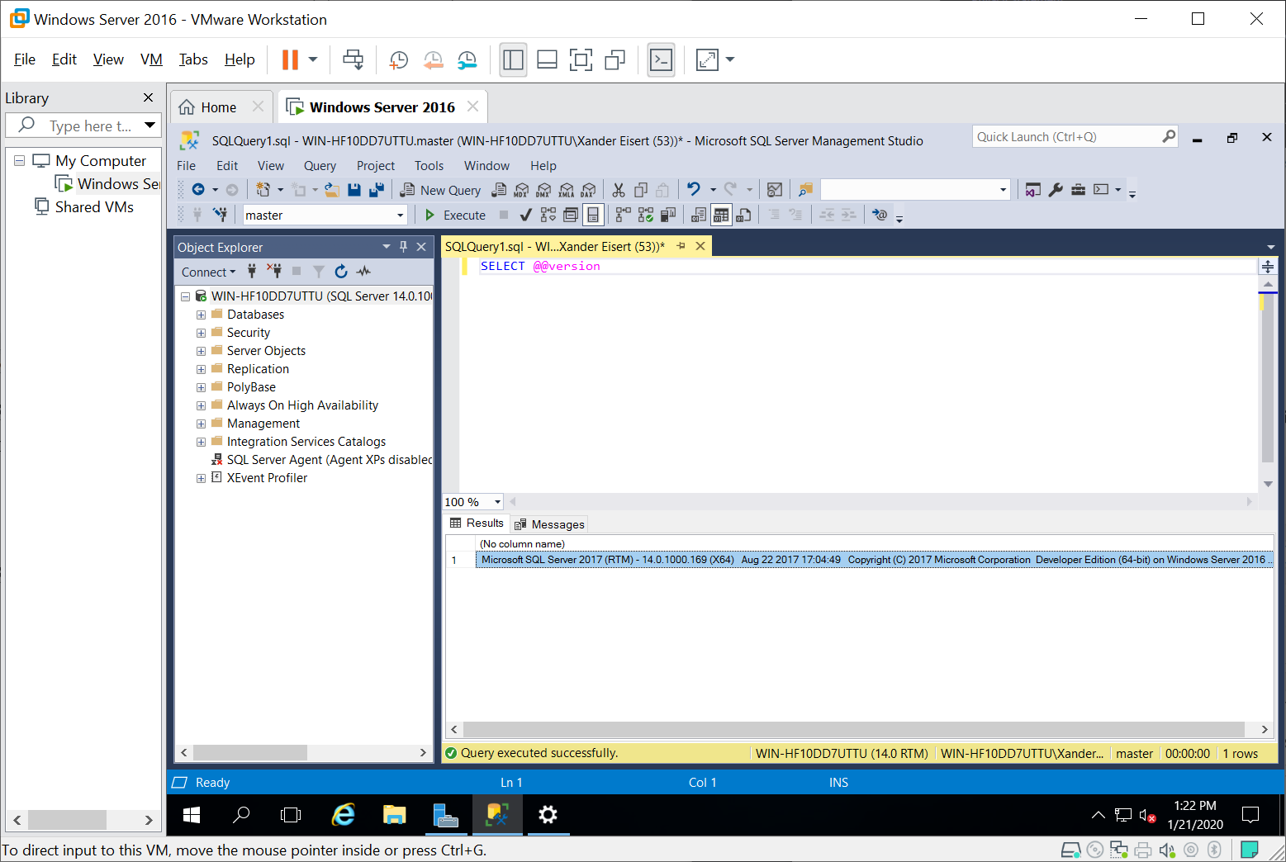

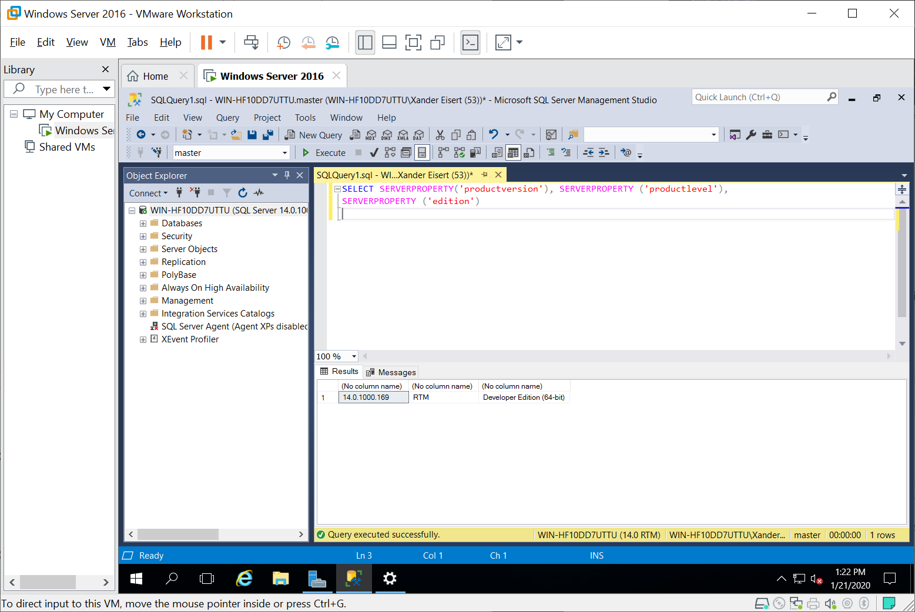

**(TASK #3: 5 points)** Show in a screenshot that the services you have installed are running.

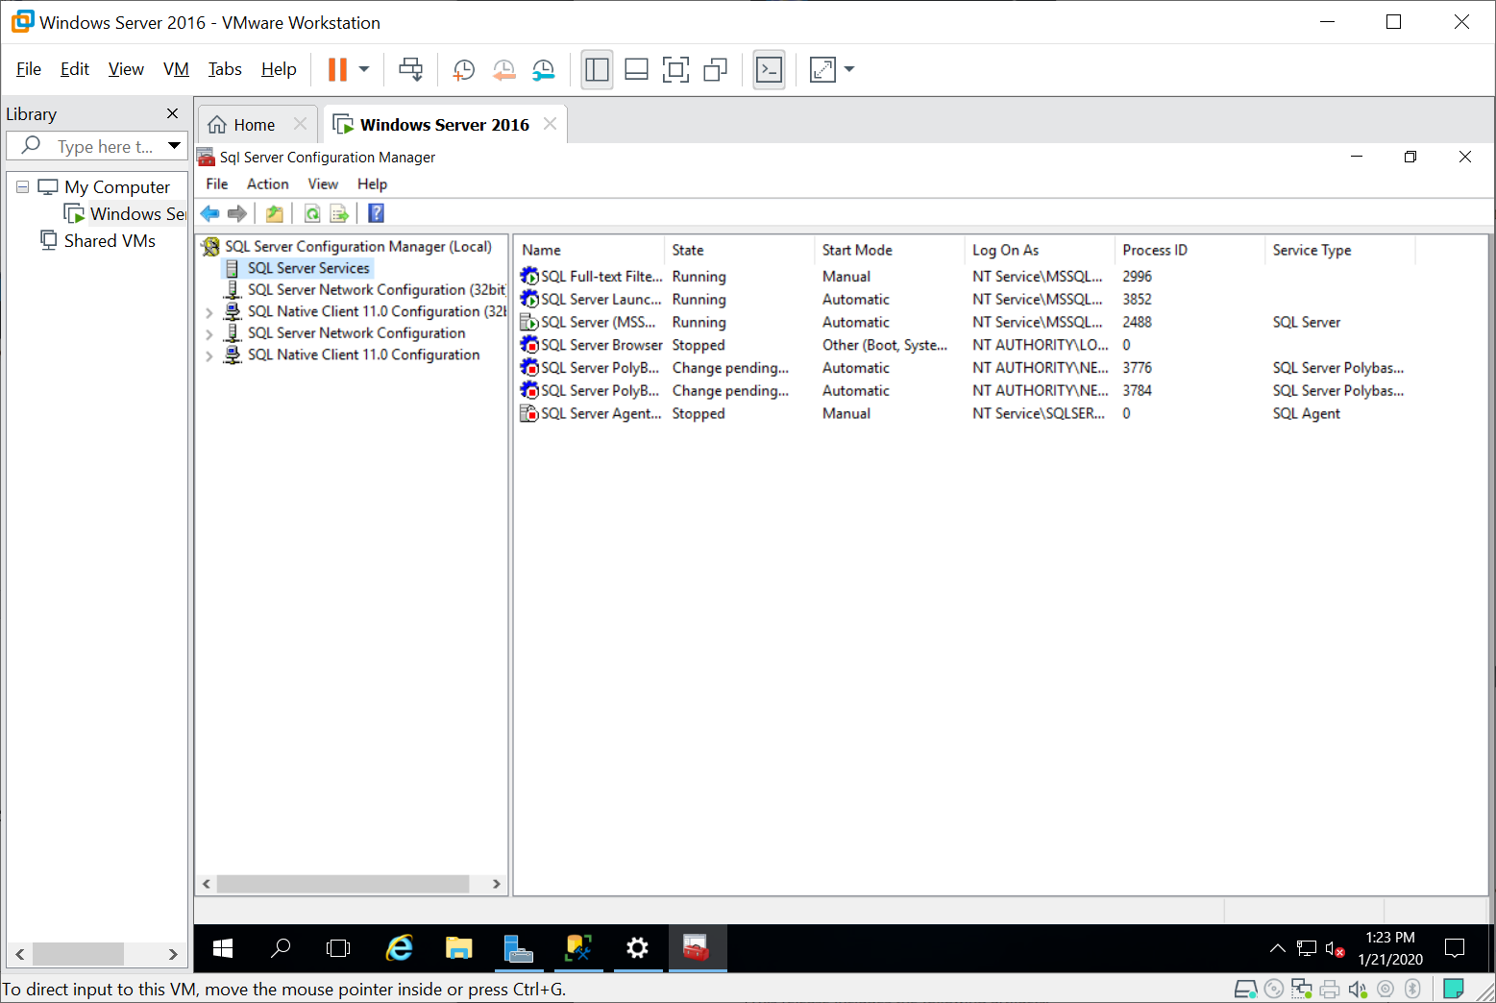

**(TASK #4: 5 points)** Execute the following query. Show the result in a screenshot.

